Dear ________________________,
We tried reaching out to you on ___________________ by phone, but were unable to connect. We’re writing to let you know that you may be eligible for a new benefit being offered by the Maine Department of Health and Human Services: The Limited Family Planning Benefit, which could help you pay for the services you received at _______________________________________ on _________________________. This letter will tell you more about this benefit and how to apply.
What is the MaineCare Limited Family Planning Benefit?

The Limited Family Planning Benefit is a limited MaineCare program that offers free and confidential family planning services. It is not full MaineCare and it is not health insurance. It covers things like:

- Yearly health checkups for both men and women
- Routine gynecologic exams
- All types of birth control, including emergency contraception
- Sterilizations for men and women
- Sexually Transmitted Infection (STI) testing and treatment
- Human Papilloma Virus (HPV) vaccines
- Other reproductive health services

If you apply and are approved, MaineCare will pay for the qualifying health care services you recently had and will also cover these services for a year.

How do I know if I qualify for the benefit?

To qualify for the Limited Family Planning Benefit:
- Your individual income (if you are married, only your income counts) before tax needs to be at or below $496 a week. This is the weekly income of someone who earns $2,251/month or $25,808 per year. This is your income only, not including the income of anyone else living in your household.
- You need to be a Maine resident.
  - If you are a Legal Permanent Resident, you need to have had this status for at least 5 years in order to be eligible. This 5 year wait does not apply if you have been granted Asylum.

If you are not sure if you qualify, please give us a call.

What if I have Hospital FreeCare?
If you have a card that looks like this with your name on it, you have FreeCare and it is now required that you apply for the Limited Family Planning Benefit. If you choose not to apply for the Limited Family Planning Benefit, any care that would be eligible had you applied will be your responsibility to pay as it will not be covered by FreeCare.
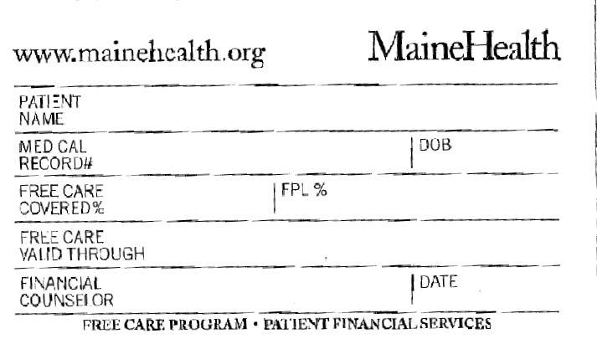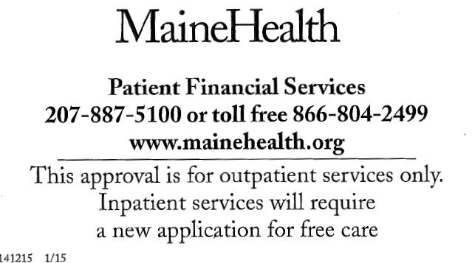
How do I apply?

- Complete the Application for Health Insurance & Authorization to Release Information Consent Form.
- Sign & date the form in 2 places: Section 12 and at the bottom of the last page

- Provide proof of your income.

- If you get paystubs, send us a copy of all your pay stubs from month of _________________ through your most recent pay period.
- If you are self-employed, please send us a copy of your tax return in place of pay stubs.
- You do not need to send income information for anyone else in your household other than yourself.

If you do not have any income, you do not need to send us anything other than the application.

- Mail both the application and your proof of income to us in the postage-paid envelope. We will send your application to the Department of Health and Human Services (DHHS) and follow its progress.

Your application will be reviewed by DHHS. If you are found eligible for this benefit, an award letter with a white MaineCare card will be mailed to you -- show this card at check-in when you go to the doctor. Please note: this is a limited MaineCare benefit for care related to sexual and reproductive health. It is not full MaineCare coverage, and does not meet the Affordable Care Act requirement to have health insurance.

If you have any questions about the Limited Family Planning Benefit or need help filling out the enclosed application, please call us at 662-7957 or 662-7947.

Sincerely,
Kathy Pipkin
Coverage Coordinator
MaineHealth Access to Care

